1. What is Projection in LINQ?

Projection in LINQ is nothing but a mechanism that is used to select the data from a data source. You can select the data in the same form (i.e. the data in its original form). It is also possible to create a new form of data by performing some operations on it. So in simple words, we can say that Projection is an operation that converts an object into a new form that holds only those properties as per our requirements.

1. What are Projection Methods or Operators Available in LINQ?

There are two methods available in the projection operator category in LINQ. They are as follows

**Select**

**SelectMany**

1. LINQ Select Operator and Select Method using C#:

The LINQ select Projection operator or Select Method can be used to format the result of the query as per our requirement. This Operator or Method can be used to return a scaler value, a custom class, or a collection of custom classes. or anonymous type which includes properties as per our business requirements.

In the same way, the LINQ Select operator or Select Method also allows us to specify what properties we want to retrieve. Whether we want to retrieve all the properties or some of the properties, we need to specify in the Select Operator or in the Select Method. The standard LINQ Select Operator or Select Method also allows us to perform some calculations

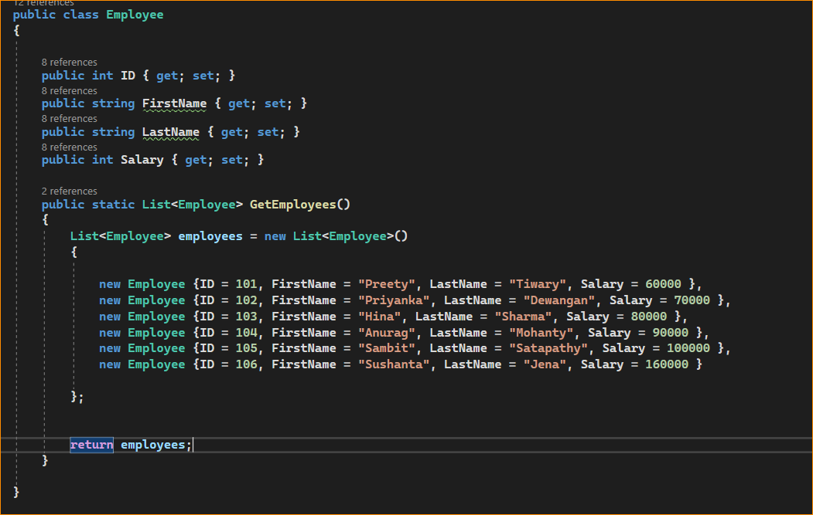

As you can see we have created the Employee class with the four properties such as ID, FirstName, LastName, and Salary. We also created one static method which will return the hard-coded list of employees which will act as our data source. Let us discuss some examples to understand the LINQ Select Operator or Select Method. The point that you need to remember while using the Query Syntax, I will use the term Select as Operator and while using the Method Syntax I will use the term Select as Method.

1. Example to Understand LINQ Select Projection Operator/Method in C#:

Select all the Employee data from the data source using both LINQ Method and Query Syntax. Please have a look at the following image which shows both Query and Method Syntax to fetch all the Employees. The following image is self-explained. The point that you need to remember when we form the query, it is not executed. When we call the ToList() Method, Sum() Method, etc., or when we use the Query variable within a for-each loop, at that time only the Query is going to be executed.

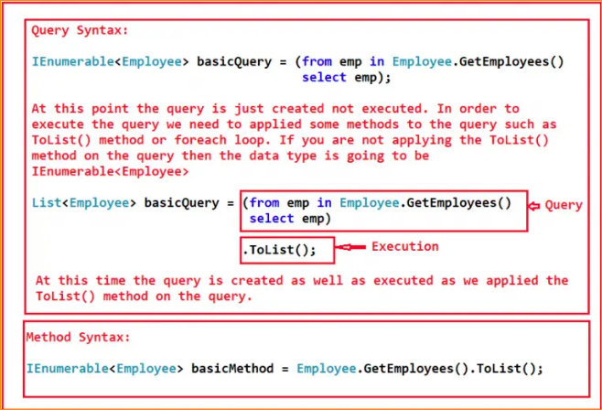

Get All Employees using Quarries and Linqs-

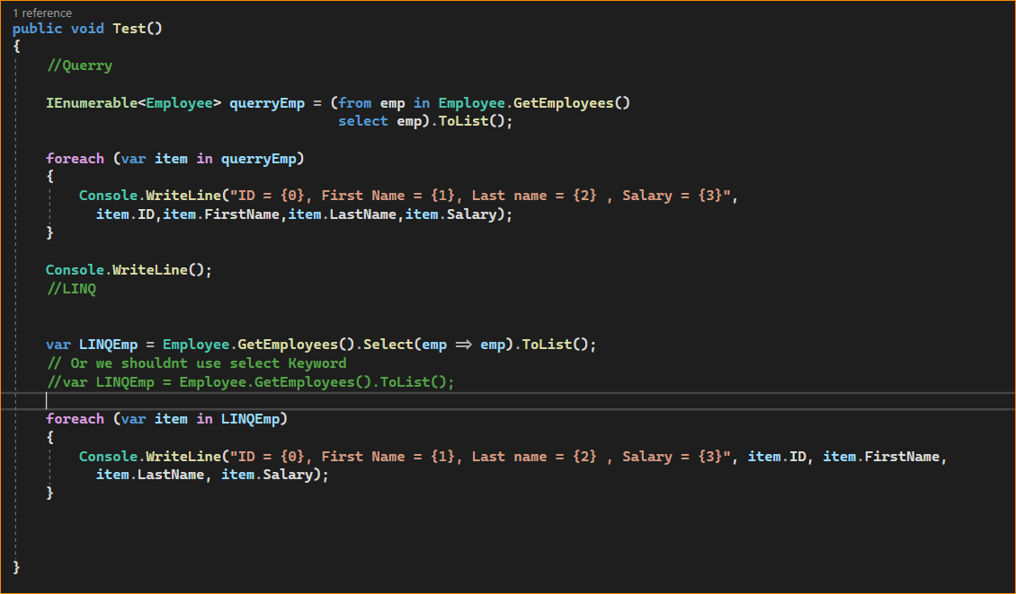

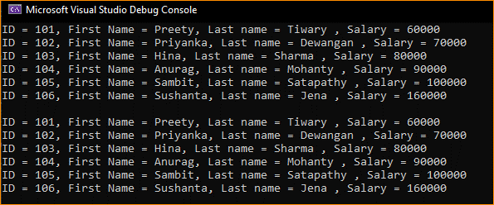

1. How to Select a Single Property using LINQ Select Operator or Select Method in C#?

Our requirement is to Select all the Employee IDs using both LINQ Method and Query syntax. In that case, within the Select Operator or Select Method, we need to specify the ID property as shown in the below image

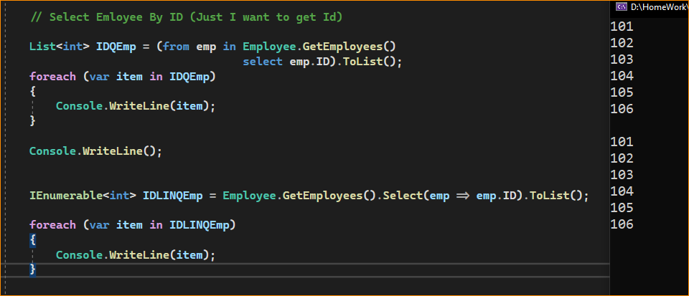

**Note:** In the Query Syntax, the data type of the basicPropQuery variable is List<int>, this is because of the ToList() method that we applied to the Query Syntax. And because of this ToList() method, the query is executed at that point only.

But in the case of Method Syntax, we have not applied the ToList() method and this is the reason why the data type of the basicPropMethod variable is of IEnumerable<int> type. And more importantly, at that point, the query is just generated but not executed. When we use the basicPropMethod variable within the for-each loop, then at that time the query is going to be executed.

1. How to Select a Few Properties using LINQ Select Operator or Select Method in C#?

Our requirement is to select only the Employee’s First Name, Last Name, and Salary properties. We don’t require you to select the ID property of the Employee

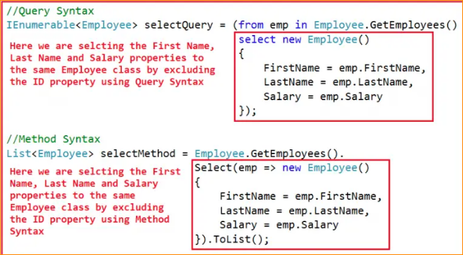

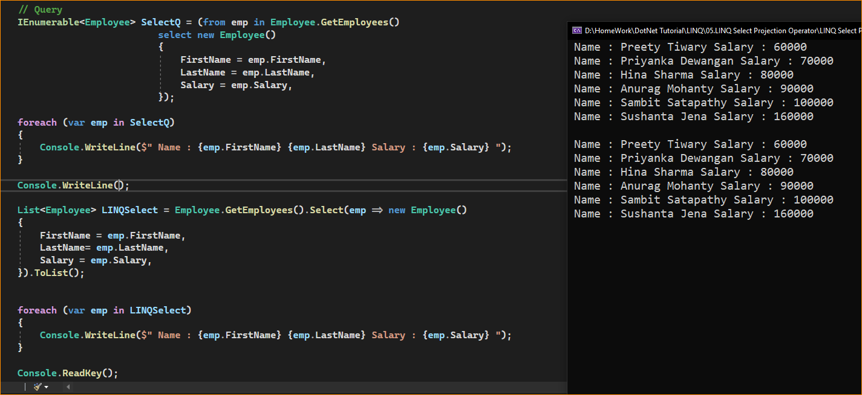

1. How to Select a Few Properties to a Different Class using LINQ Projection Operator?

It is also possible to project or select the data to a different class using the LINQ Select Operator or Select Method. In our previous example, we have seen how to select a few properties (First Name, Last Name, and Salary properties) to the same class using the LINQ Select Projection Operator. Let us create a new class with the above three properties and to this class, we will project the data. So, create a new class file with the name EmployeeBasicInfo.cs and then copy and paste the following code into it.

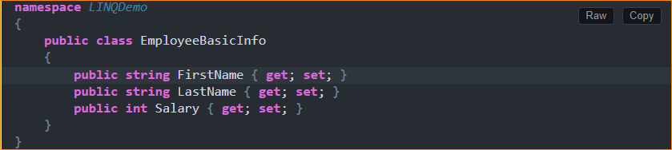

Now what we need to do here is, we need to select the First Name, Last Name, and Salary properties to the above newly created EmployeeBasicInfo class. For a better understanding, please have a look at the below image. Now, with the Select Method or select operator, we are not creating an instance of the Employee class, rather we are creating an instance of the EmployeeBasicInfo class and populating the FirstName, LastName, and Salary properties from the data source which we can access using the emp object.

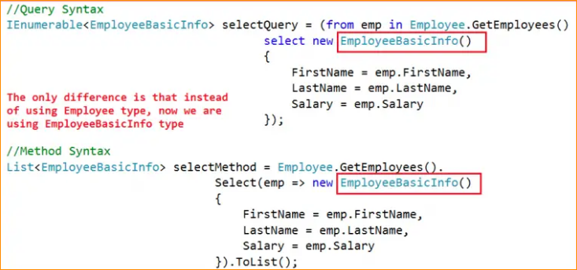

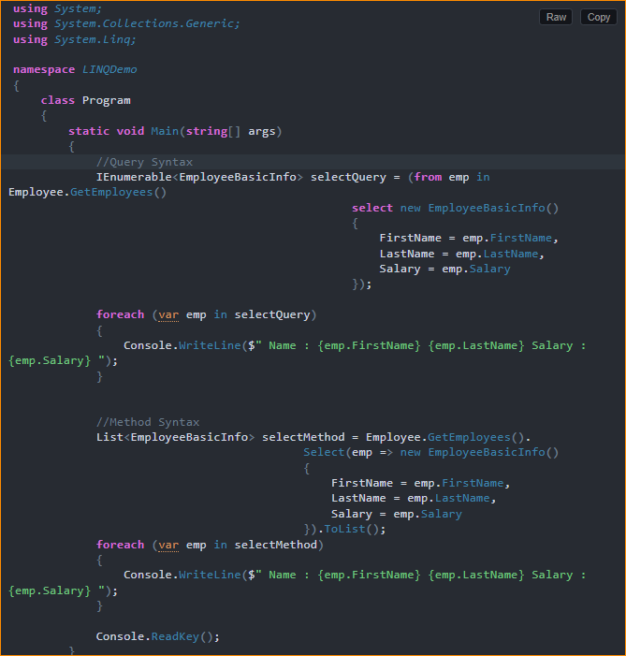

1. How to Project the Data to Anonymous Type using LINQ Select Operator/Method?

nestead of projecting the data source data to a particular type like Employee or EmployeeBasicInfo, we can also project the data to an anonymous type in LINQ using the Select Method or select operator

For a better understanding, please have a look at the below image. Here, we are creating an anonymous object (i.e. creating an object without specifying the type) and creating and populating the FirstName, LastName, and Salary properties from the data source which we can access using the emp object.

We can do **calculations** Also,

1. How to Perform Calculations on Select Data using the LINQ Projection Operator?

Let me first explain what we want to achieve. We want to perform the following calculations on the selected employee data. That means we need to calculate the Annual Salary and we need to merge the First Name and Last Name as Full Name in the output.

**AnnualSalary = Salary*12**

**FullName = FirstName + ” ” + LastName**

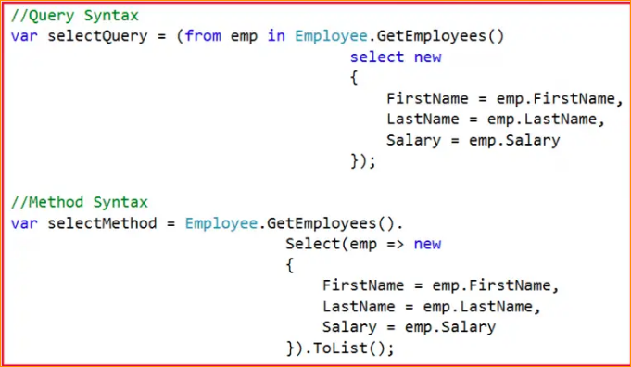

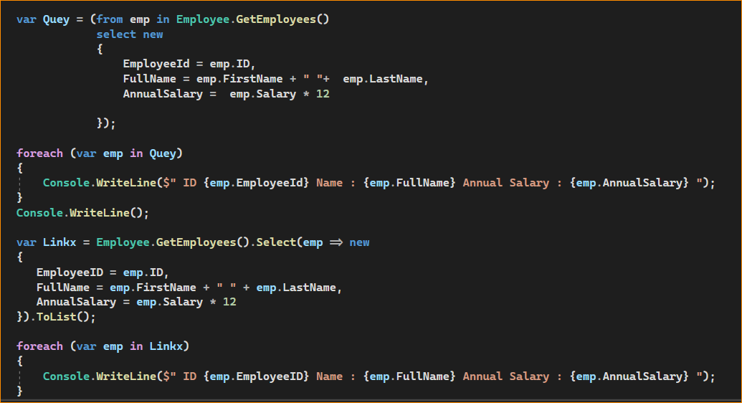

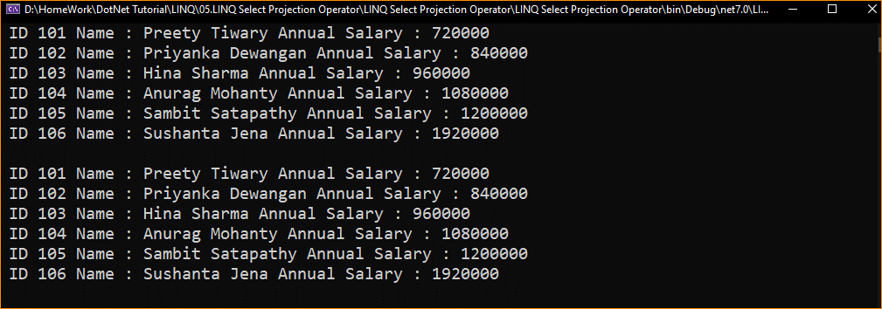

1. How to Select Data with Index Value using LINQ Select Projection Operator?

It is also possible to select values using an integral index. The index is 0 based. If the query fetches five records, then the index will be from 0 to 4. It’s basically a unique value to each record that we select or project from the data source.

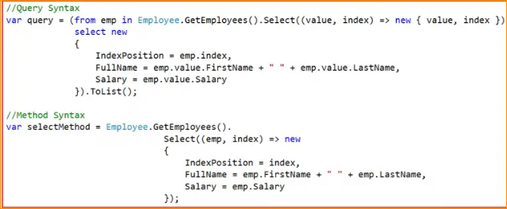

1. How to Select Data with Index Value using LINQ Select Projection Operator?

It is also possible to select values using an integral index. The index is 0 based. If the query fetches five records, then the index will be from 0 to 4. It’s basically a unique value to each record that we select or project from the data source.

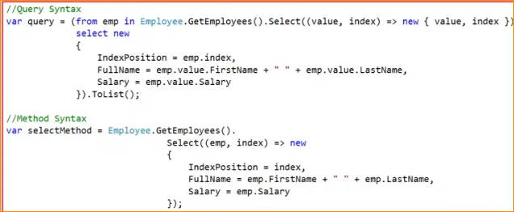

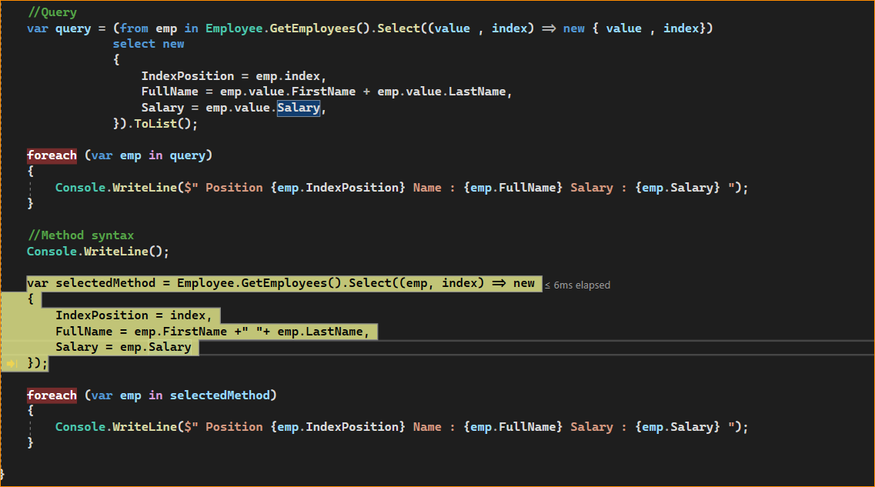

Output –

